`
Third Grade News from Sr. Noel’s Class (May 7-11 )
sr.noel@sjb-school.org, http://grade3-sjbschool.weebly.com
Language Arts  The power of the Magnets (continue--)  -use the cause and effect, sequence of events  This week we will  Read “ A new Team of Heroes”  - identify character traits  - monitor and clarify understanding of an article  Grammar & Writing  - write a poem  - create a brochure  - create an award certificate | Bible Verse for the Week  “Do not be conquered by evil but conquer evil with good.” (Romans 12:21)  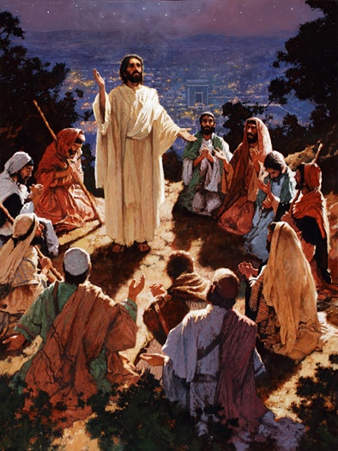  Dates to Remember  May 1- 30 - Reading Adventure , group meeting on Wednesdays at 10:15  May 7 - NWEA math test  May 9 – RA at 10:30, bring reader verification form this day  May 11- Picturing America  May 14- Spring Musical  May 16- Social Studies test  May 16 –Class Mass at 9 : 00(not on the 23rd)  May 23 –Class Field Trip to “Sea –Life” . Students will take their lunch along. Class at 11:30 and lunch at 12:15, self directed aquarium tour after the lunch. We have enough drivers/chaperones signed up for the field trip. Thank you parents and grandparents for volunteering. | Vocabulary: Lessons 28 & 29  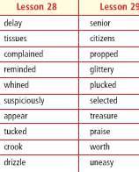  Spelling: Lesson 28 & 29  Assignments: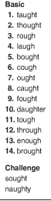 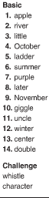  May 16- spelling test # 27  May 21- Spelling test # 28 (lessons 28&29)  Spelling words write 2 X in cursive  Just a note:  Please refer dress code for the church and school
Math
This week we will
-study Multiplication facts 1-12
NWEA test
Science
Adaptations:
-recognize organisms that survive in certain environments, animals and plants that live in the ocean
-research on water habitats
Weekly Reader
Social Studies
Government : Chapter 8
We will learn
Test Chapter 7 (P.232 – 263)
Religion
Lesson 17 - The Church Is a Sign of the Kingdom of God.
We will
- learn about the Kingdom of God
- understand who will be welcomed to the Kingdom
- describe the Kingdom of God
- describe a place of peace and happiness

