`
Third Grade News from Sr. Noel’s Class (April 16 – 20 )
sr.noel@sjb-school.org, http://grade3-sjbschool.weebly.com
Language Arts  This week we will  - read an informational text, “ Mountains: Surviving on Mt. Everest”  Target Skill: Text and Graphic Features  Grammar & Writing  - adverbs, prefixes, and prepositions  –write a fictional narrative story  - writing narrative poems | Bible Verse for the Week  I am the good shepherd I know my sheep and my sheep know me. (John 10:14)  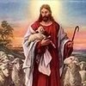  Dates to Remember  April 20 – Library and Poetry/Pause today  May 23 – Field Trip to “Sea –Life” at Mall of America 10:30 -2: 30  We need drivers and chaperones  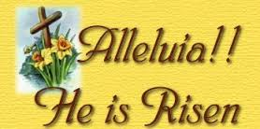 | Spelling &Vocabulary: Lesson 25  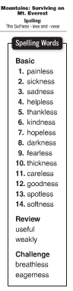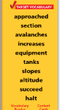  April 23 - Spelling test # 25  Spelling words – do one spelling activity due Friday  Assignments and homework:  Reading : Unit 5 – “Going Places”  Read leveled books on Think Central  Read: Text pages – 296 – 317 to be read at home this week  Extra credits text p. 318 – 321 to read and do the activity at home by Mon., April 25  Math: practice on iXL, you can do only 10 questions on a computer
Math
Unit 6: Geometry (p. 382- )
This week we will
-identify parallel and perpendicular lines
-describe and create geometric shapes, such as right triangles, parallelograms, trapezoids, rhombuses and rectangles
Science
April 18 – Science Test - Forces and Energy
( Text p. 432 -475)

Social Studies
Citizens and Government
-understand and apply some rights of citizens
-identify and explain the voting process
Religion
Lesson 14: “ We Are Committed Through the Sacraments”
We will
- learn about the Sacraments of Matrimony and the Sacrament of Holy Orders
-explore the meaning of commitment
-identify the types of vocations

