`
Third Grade News from Sr. Noel’s Class (April 8 – 12 )
sr.noel@sjb-school.org, http://grade3-sjbschool.weebly.com
This week we will  Language Arts  - read a realistic fiction,“ Dog of the Sea- Waves”  - determine the author’s purpose  Grammar & Writing  - spell words with prefixes  - identify adverbs that tell when, where and how  - write to express – write a narrative poem | Bible Verse for the Week  I came into the world as light, so that everyone who believes in me might not remain in darkness.  (John 12:46)  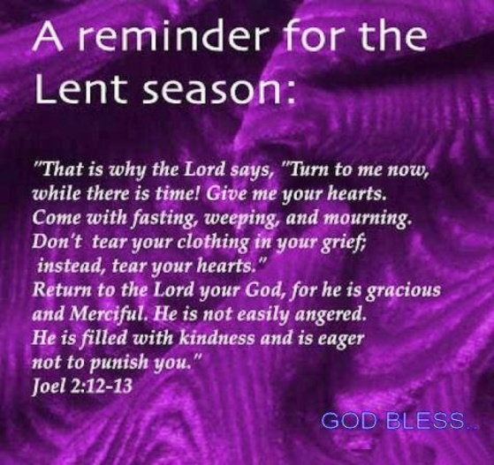  Dates to Remember  Thank you for all who helped us with the Bingo Fun Day  April – 8 – Stations of the Cross (Gr. 3)  April 10 – Class Mass (All are Welcome)  April -11 – Picturing America (Thank you Jamie R for teaching this art)  April 12 - Lenten Retreat  April 24 – Science Test - Forces and Energy  ( Text p. 432 -485)  April 26- Poetry/pause (2:25pm)  Bingo Fun Day: Thank you Jamie R for putting together class silent auction basket. The 3rd grade students also donated an art work that designed and painted by the students. They priced it $40.00 | Vocabulary & Spelling: Lesson 24  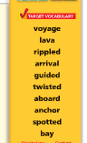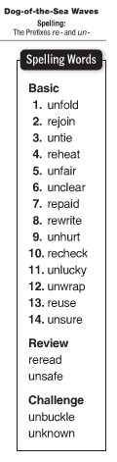  April 15- spelling test # 24  Spelling words write 2 X in cursive by Friday  Assignments:  Reading : Unit 5 – “Going Places”  Read: Text pages 266 – 287  Extra credits text p. 288 – 291  Math: IXL –CC.1 to DD.8  Language: JJ.2 to JJ.14
Math
Unit 6: Geometry (P. 382- )
-identify parallel and perpendicular lines
-describe and create geometric shapes, such as right triangles, parallelograms, trapezoids and rectangles
Science
Forces and Energy
Simple Machines
Social Studies
Citizens and Government
-understand and apply some rights of citizens
-identify and explain the voting process
Religion
Lesson 14: “ We Are Committed Through the Sacraments”
- learn about the Sacraments of Matrimony and the Sacrament of Holy Orders
-explore the meaning of commitment
-identify the types of vocations
-pray the Stations of the Cross
-prepare for Sacrament of Reconciliation

