`
Third Grade News from Sr. Noel’s Class (4/29-30, 5/1-3)
sr.noel@sjb-school.org, http://grade3-sjbschool.weebly.com
Language Arts  The power of the Magnets  This week we will  -use the cause and effect, sequence of events  Grammar & Writing  - writing quotations  - write to inform  - compare and contrast poems | Bible Verse for the Week  “He Gives Me Peace.” ( John 14:27)  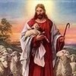  Dates to Remember  May 1- NWEA Reading  May 1 – Reading Adventure Kick-off at 3:05  May 2 – NWEA Language  May 3 , Library – last day to check out books  May 7- NWEA Math  May 8,15, and 22 - Reading Adventure at 3:05  May 10 –Rosary, Gr. 3  May 15-Class Mass  May 17- All School Field Trip | Spelling & Vocabulary: Lesson 27  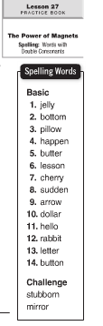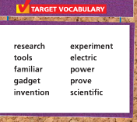  May 8 - Spelling Test Lesson 27  Assignments  Read Book : “Make Your Mark” P. 20 -33  Math: practice on IXL  Write spelling words 2X in cursive and work with Vocabulary
Math
-review math skills
NWEA –test
Multiplication 1-12
Science
Adaptations:
-recognize organisms that survive in certain environments, animals and plants that live in the ocean
-research work on water habitats( we will start in class)
Social Studies
Unit 6 - Working in Communities
Chapter 8 review and test

Religion
Lesson 16 - We Pray for Faith ”
- understand that the beliefs of the Catholic Church are in the Apostles’ Creed
- explore the meaning of the of the Apostles’ Creed
- pray the Apostles’ Creed

