Third Grade News from Sr. Noel’s Class (Sept. 4 -7 , 2018 )
sr.noel@sjb-school.org, http://grade3-sjbschool.weebly.com
Language Arts  This week we will be reading a Humorous fiction.  Students will learn the story structure and will summarize the story.  Grammar: complete subject and complete predicate  Writing : write to narrate (descriptive paragraph) | Bible Verse for the week  Isaiah 41:10  “Do not fear: I am with you; do not be anxious: I am your God.  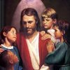  Upcoming Events  Sept. - 10 Pizza Lunch begins  Sept. - 12 Third Grade Class Mass  Sept. - 30 Parish Festival  Oct. – 03 Field trip to Heritage Village  We need volunteer parents to drive/chaperone. Please let me know if you can.  Fall Festival – need a parent volunteer to put together a basket for silent auction | Spelling & Vocabulary: Lesson 1  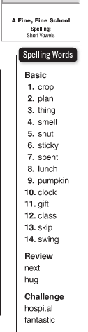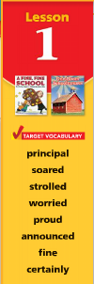  Reminders:  - Illustrate 2 Vocabulary Words  - Read text page 10-36  - Challenge activity is in Text p. 37  - Spelling test on Monday Sept. 10  - School spirit – Monday - Thursday
Math
This week we will
- review 2 digit addition, subtraction, fact family, inverse operations
- identify property of addition
- grouping property of addition
- review test
Science
Students will
- understand caterpillar changes into a butterfly
- identify the steps in the scientific method

Social studies
Introduction: Five themes of Geography
Weekly Reader
Map and Globe skills
Religion
Students will learn
- what is in the Scripture
- how to use the Scripture
- find passages and learn Scripture Verses

