Third Grade News From Sister Noel’s Class (Nov. 26-30)
sr.noel@sjb-school.org, http://grade3-sjbschool.weebly.com
This week we will be learning:  Language Arts  -reading a biography lesson “Young Thomas Edison”  Key skills  -main ideas &details; summarize  Grammar & Writing  - pronouns  - concrete poem/story  Handwriting: cursive letters (p.79 – 83) | Give thanks to the Lord, for he is good; his love endures forever. (Psalm 118:1)  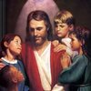  Dates to Remember  Nov. 28 – Class Mass, show & Tell  Nov.30 – “Book It” form due  Nov.30 – Library  BOOK IT:  Required Reading goal for November is 250 minutes. For Super Reader Award read 500+ minutes. | Vocabulary &Spelling: Lesson 10  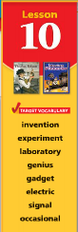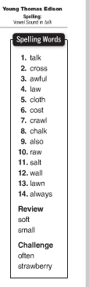  Spelling test: Lesson 10 on Monday, Nov. 26  Assignments:  Read : “Young Thomas Edison” P. 322 - 349  Extra credit - Text P. 350 – 353 ( For those who are not done yet )  Reading: Unit 2 test (Lessons 6-10)
Math
Unit 2
- review Lessons 4-7
Unit 3
Multiplication Concepts and Facts
- connect addition and multiplication
- multiply with 2, 3 & 5
Science
Living things in Ecosystems
Weekly Reader
Social Studies
Unit 3: Communities Over Time (Text p. 145 -232)
Map and Globe skills

Religion
-explore the meaning of the Great Commandment
-understand that Jesus teaches the Good news with authority of God ( Chapter 7)
- study Scripture Verses
- saint of the week – Louise de Marillac
- saint of the month – Padre Pio
-virtue - humility

