Third Grade News from Sister Noel’s Class (Jan. 2-11, 2019
Sr.noel@sjb-school.org , http://grade3-sjbschool.weebly.com
This week we will be learning:  Language Arts  - reading an informational text “ Aero and officer Mike” (police partners)  Key skill  -author’s purpose  Spelling, Grammar & Writing  - contractions  - vowel + r sounds  - pronouns and verbs  -write to narrate ( autobiography)  Handwriting: cursive writing | BIBLE VERSE FOR THE WEEK  “Be Merciful, just as your Father is merciful.” (Luke 6:36)  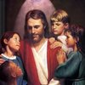  Dates to Remember  Jan. 2 - Class Mass, show and tell  Jan. 3 - Picturing America  Jan. 4 - Christmas party (2:30)  Jan. 12- Library  Jan.14 - Test Ch. 8 (P. 314 – 355)  Jan. 25 - Library (Thur.)  Jan. 27 - Catholic Schools Week – All School Mass  HAPPY NEW YEAR | Vocabulary &Spelling: Lessons 14  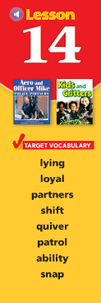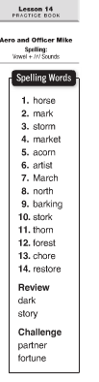  Jan. 7 - spelling test ( Lesson14)  Assignments:  Read - “ Aero and officer Mike” P. 456 – 481  Spelling and vocabulary work due Jan. 7
Math
- connect addition/ multiplication, division/ subtraction
- geometry
- study multiplication facts 1-10
Science
Planets, Moons, and Stars
Lego Robotic Lesson – build, program, and present
Social Studies
Our Country’s History
Map and Globe skills
Religion
-understand that scripture reveals that Jesus offers living water ( Lesson 9)
Church Year – The Season of Incarnation
Virtue of the month: Fidelity - Being faithful to promises and commitments
Saint: Bls. Luigi & Maria Quattrocchi

