Third Grade News from Sister Noel’s Class (Jan. 14 - 17, 2019)
Sr.noel@sjb-school.org , http://grade3-sjbschool.weebly.com
This week we will be learning:  Language Arts  Reading a humorous fiction “ A Mr. Rubbish mood from Judy Moody saves the World”  Key skill  -author’s purpose  -context clues  Spelling, Grammar & Writing  -adjectives  -write to persuade – persuasive letter  Handwriting: cursive writing | BIBLE VERSE FOR THE WEEK  This is my commandment: love one another, as I have loved you. (John 15:12)  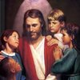  Dates to Remember  Jan. 17 - Unit 3 test  Jan. 25 - Library  Jan. 27 - Catholic Schools Week – All  School Mass  It is about half of the school year is over. Because we are working hard in 3rd grade, some of our supplies are about to gone. Students need to have a box of regular wooden pencils (12-24) and a working, hand pencil sharpener in the supply box. | Vocabulary &Spelling: Lesson 16  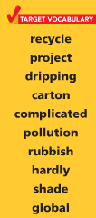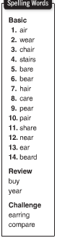  Spelling test Tuesday 22, 2019  Assignments:  Write spelling words 2X in cursive (due Tuesday 22)  Reading : Unit 4 – Extreme Nature (2nd book)  Read Text p. 10 – 33
Math
This week we will
- collect and organize data, classify data & read and interpret data
- find the mean and median of a set of data
- study multiplication facts 1-10

Science
Planets, Moons, and Stars
Robotics
Weekly Reader
Social Studies
Our Country’s History (p. 189 -230)
Map and Globe skills
Religion
We Gather for Mass (Lesson 10)
-explore the celebration of the Liturgy
- study scripture verses

