Third Grade News from Sister Noel’s Class (Jan. 28 – Feb. 8, 2019)
Sr.noel@sjb-school.org, http://grade3-sjbschool.weebly.com
This week we will  Language Arts  -continue Lesson 16  -read an informational text “The Albertosaurus Mystery”  Key skill  - learn to draw conclusions  Spelling, Grammar & Writing  -adjectives and articles  -write to persuade – persuasive letter/ opinion paragraph  Handwriting: cursive writing | BIBLE VERSE FOR THE WEEK Love is patient, love is kind. It does not envy, it does not boast, it is not proud.  ( 1 Corinthians 13 : 4)  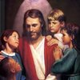  Dates to Remember  Jan. 31- due“Book It” (require 250 min, you may read more on these days  Feb.6- Handwriting contest  Feb. 7 -Picturing America?  Feb. 13- Class Mass (Gr. 3)  Feb. 13 - JA class at 2:35  Feb- 14 - Valentine’s Day party  Feb. 20 - President’s Report due (will send the materials this Friday)  2019 – We will participate in Mission Writing Conte  Please do on these cool days- Read Theory, Khan academy and IXL( 10 questions each for math, language, social studies and science every day | Vocabulary &Spelling: Lesson 17  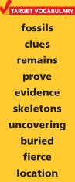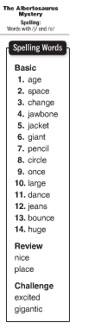  Assignments:  Spelling test lesson 17 on Feb. 11, 2019  Math: study multiplication facts 1-12. See the assignments in the Google classroom and do if you can.  Write: spelling words 2 X in cursive 1 X in printing (due Feb.8) Please write a creative story using the above vocabulary words and as many spelling words. Underline the vocabulary and spelling words you used in your story( work today and tomorrow)  Reading : Unit 4 – Extreme Nature  Read Lesson 16 p. 13 - 35(Take book home this Friday)
Math (Chapter 15)
Analyze and Graph Data
- collect and organize data, classify data & read and interpret data

Science
Earth, Sun, Moon and Planets
Robotics
Weekly Reader
Social Studies
Our Country’s History (p. 189 -230)
Map and Globe skills
Religion
Mission Education
-identify the qualities of a good messenger
-explore the meaning of grace
-describe ways to be a missionary
-study scripture verses

