Third Grade News from Sr. Noel’s Class (3/4 - 8 )
sr.noel@sjb-school.org, http://grade3-sjbschool.weebly.com
This week we will  Language Arts  - read an informational text, “Life on the Ice”  - focus on main ideas and details  - read Donavon’s Word Jar  -identify the characters  Grammar & Writing  -irregular verbs, contractions, compound words  -write a persuasive essay | BIBLE VERSE FOR THE WEEK  “It is in Jesus that our sins have been forgiven because of God’s great love.”  Ephesians 1:7  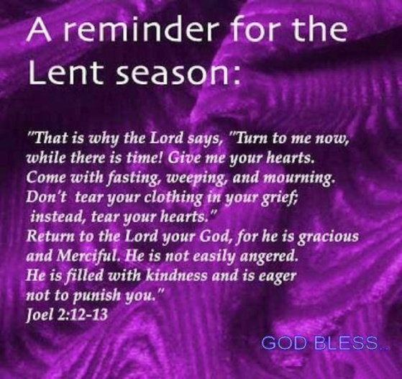  Dates to Remember  Mar.6 – Ash Wednesday  March 7- Science Fair Abstract due for me  Mar.08 - Science Fair  Mar. 20 - JA class at 2:35  Mar.25 – Grade 3 leading the Stations of the Cross  Have A Happy Season of Lent! | Vocabulary &Spelling: Lesson 20  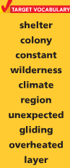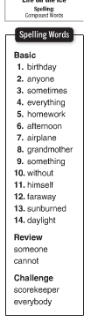  Spelling test - March 5  Assignments:  Write Spelling words 2X  Read leveled books ( at home or at school)  Read Text p. 136 – 157  Extra Credits P. 158 -161 (Home work)  Vocabulary work: write the words, find the definitions, and parts of speech. Illustrate 2 words, you may use your reading notebook, due March 7
Math
Metric Units and Temperature
- study multiplication facts 1-12
Science
Physical Science
Properties of Matter (p. 362 – 391)
Social Studies
Mar.18 - Test (P.189 -225)
Map and Globe skills
Weekly Reader
Religion
Lesson 12 – We Pray for all People
- identify the qualities of a role model
-understand that Blessed Mother Mary is a good role model
- learn about the Rosary
-study scripture verses
- pray the Stations of the Cross

