`
Third Grade News from Sr. Noel’s Class ( 4/1 – 5/ 2019 )
sr.noel@sjb-school.org, http://.grade3-sjbschool.weebly.com
This week we will  Language Arts  - read a fantasy story, “The Journey of Oliver K. Woodman”  -tell sequence of events  Grammar & Writing  - abbreviations, suffixes  - write to express – descriptive paragraph  - writing narrative poems | Bible Verse for the Week  Where two or three are gathered together in my name, there am I in the midst of them. (Matthew 18: 20)  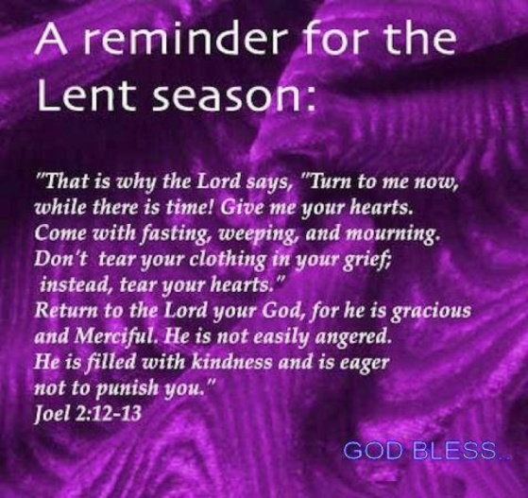  Dates to Remember  April 01- Book It Reader Form Due today  April 03 – JA (last class)  April 04 – Picturing America  April – 05- Library  April – 08 Stations of the Cross (Gr. 3)  April 10 – Class Mass ( Parents are Welcome)  April 12 – Students Lenten Retreat (1:00 -3:00)  April - 07 – Bingo Fun Day: Thank you Jamie R for organizing the Silent Auction Class Basket  A note from Jamie R: With Bingo Fun Day approaching, the 3rd grade class will have a basket "Gardening" theme.” If you could, please send in $5 to go towards the basket, or donate any gardening supplies, that would be great!  Thanks!  Jamie Reinardy | Vocabulary & Spelling: Lesson 23  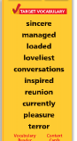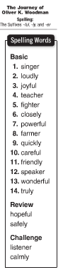  Spelling test Lesson 23, April 8  Assignments and homework:  Reading : Unit 5 – “Going Places”  Read: Text pages – 230 – 259  Extra credits text p. 258 – 259  Homework/Class work:  Language Arts : IXL –Analyzing literature-  G.1 – G.6  Math : IXL – Comparing Fractions and Operations with Fractions – Y.1 -12 and Z.1 to 8
Math
- continue data and measurement unit
- test unit 5 on Friday, (Lessons 15-18)

Science
Forces and Energy: Text P. 432 – 473
Lesson 3- Work and Energy

Social Studies
Citizens and Government
-understand and apply some rights of citizens
-identify and explain the voting process
Religion
Lesson 14 “ We Are Committed Through the Sacraments”
- realize that God wants us to keep our promises to serve.
- pray the Chaplet of Divine Mercy
- pray the Stations of the Cross

