`
Third Grade News from Sr. Noel’s Class (April 15 – 18 )
sr.noel@sjb-school.org, http://grade3-sjbschool.weebly.com
This week we will  Language Arts  - read an informational text, “ Mountains: Surviving on Mt. Everest”  Target Skill: Text and Graphic Features  Grammar & Writing  - adverbs, prefixes, and prepositions  - writing narrative poems | HOLY WEEK  Dates to Remember  April 18 – Library  April - 19 - Good Friday  April – 20 – Holy Saturday  April – 21 - Easter  April – 26 - Poetry/Pause | Spelling &Vocabulary: Lesson 25  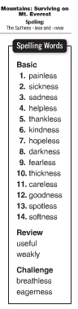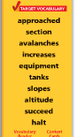  April 23 - Spelling test # 25  Assignments and homework:  Spelling/Vocabulary activity due: Wed. 24th  Reading : Unit 5 – “Going Places”  Read: Text pages – 296 – 317  Extra credits text p. 318 – 321  Math: IXL EE.1 to-EE.5 and DD.1 to DD.8  Language Arts : G 1 to G.6
Math
Unit 6: Geometry
-identify parallel and perpendicular lines
-describe and create geometric shapes - right triangles, parallelograms, trapezoids, rhombuses and rectangles
Science
Forces and Energy - Text P. 432 -475
Social Studies
Citizens and Government – Text P – 233 - 312

Religion
Lesson 14: “ We Are Committed Through the Sacraments”
- pray the Stations of the Cross
Holy Week (Text P. 342 – 347)

