`
Third Grade News from Sr. Noel’s Class (May 13-24 )
sr.noel@sjb-school.org, http://grade3-sjbschool.weebly.com
This week we will  Language Arts  Read : 1.The Power of the Magnets (continue--)  2- Becoming Anything He Wants to Be  3 - A new Team of Heroes”  - identify character traits  - monitor and clarify understanding of an article  -use the cause and effect, sequence of events  Grammar & Writing  - write a poem  - create a brochure  - create an award certificate | Bible Verse for the Week  “Do not be conquered by evil but conquer evil with good.” (Romans 12:21)  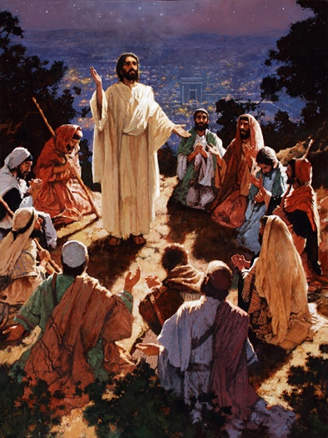  Dates to Remember  May 1- 29 - Reading Adventure , group meeting on Wednesdays at 3:05  May 13- Spring Musical  May 15 – RA at 3:05 bring signed reader verification form this day  May 15 –Class Mass  May 17 – School Field Trip  May 17 – Rosary at 3:00  May 31 – Rosary procession  IXL: Language Arts L 1 to 3 and Social Studies H 1 to 4  Math F. 1 to 13 and H. 8 | Vocabulary: Lessons 28 & 29  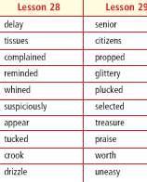  Spelling: Lesson 28 & 29  Assignments: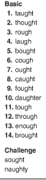 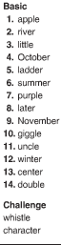  May 14- spelling test # 28  May 24- Spelling test # 29  IXL Math: K. 16, M. 7, FF. 9, U. 13, C 12 etc. & more Multiplication
Math

Study multiplication facts 1-12
Science
Adaptations:
-recognize organisms that survive in certain environments, animals and plants that live in the ocean
-research on water habitats
Weekly Reader
Social Studies

Unit 6 - Working in Communities
Religion
Lesson 17 - The Church Is a Sign of the Kingdom of God.
- learn about the Kingdom of God
- understand who will be welcomed to the Kingdom
- describe the Kingdom of God
- describe a place of peace and happiness

