Third Grade News from Sr. Noel’s Class (Sept. 24 - 28 , 2018 )Working one
sr.noel@sjb-school.org, http://grade3-sjbschool.weebly.com

This week we will be learning:  Language Arts  Reading: Historical fiction.  Key skill  Compare & Contrast  Grammar & Writing  - common and proper nouns  - personal narrative | Bible Verse for the week  I am the way, the truth, and the life; no one comes to the Father but through me. (John 14:6)  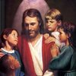  Upcoming Events  Sept. 19 - 28 – NWEA  Sept. 30 – All School Mass at 10:00  Oct. 0 3 - Field trip to Heritage Village  Permission slip and the fee for Heritage Village $ 7.00, due Sept. 28  Oct.0 5 – Marathon  Oct.10 – Class Mass  Thank You to Milinda for putting together Class Basket for our Fall Festival. This year’s theme is “Halloween Basket”. A paper copy sent home last week. Suggested donation is $ 5:00 | Vocabulary &Spelling: Lesson 4  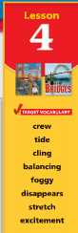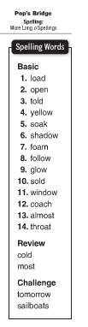  Reminders:  Work with vocabulary words  Write spelling words 2X in your Best Handwriting  Read the story, “Pop’s Bridge” P.110-137  Challenge activity ( extra credit) Text P.141  Spelling test on Monday Oct. 1st
Math

place value 5 and 6 digit numbers
- create number patterns
- compare, order, describe, predict and round numbers and create number patterns
Science
Plants and their needs
Plants and their parts

Social Studies
Map and Globe skills
Learning about communities (Text p. 13-39)
Weekly Reader

Religion
Unit 1: The Church is One : Focus on the Sacraments of Christian Initiation
Sept. 29 -Feast of the Archangels (Michael, Gabriel and Raphael)
Oct. 2 - Feast of the Guardian Angels
Oct. 4 - Feast of St. Francis

