Third Grade News Letter From Sister Noel’s Classroom (10/1 –5, 18)
sr.noel@sjb-school.org, http://grade3-sjbschool.weebly.com
This week we will be learning:  Language Arts  - reading a biography lesson.  Key skill  Cause and Effect  Grammar & Writing  - common and proper nouns  - plural nouns with –s and - es  - prefixes  - personal narrative | Bible Verse for the week  Where two or three are gathered together in my name, there am I in the midst of them. (Matthew 18:20) 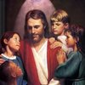  Upcoming Events  Sept. 30 –All School Mass, remember to wear your Spirit shirt  Oct. 1- Book It Starts  Oct. 3- Field Trip to Heritage Village  Oct. 3- Eucharistic Adoration 7:00 -8:00 PM in the church at SJB  Oct. 8 -Gr. 3 leads the Rosary at 3:00  Oct. 15 & 16 - Parent Teacher Conference  Oct. 22 – Saint report due ( We will start in the class)  Oct. 31- “Book It” Reader form due  Oct. 31- All Saints Halloween Party at 2:30 PM  BOOK IT: Required goal for Oct. is 250 minutes of reading and a book report. For Super Reader Award, read 500 + minutes | Vocabulary &Spelling: Lesson 5  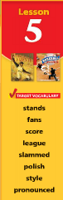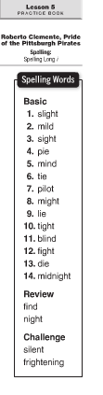  Reminders:  Work with vocabulary words  Read, “Roberto Clemente” P.146-173  Extra credit: Text P.177  Spelling test on Monday Oct. 8  Reading Practice book p. 57 – 70 by Wednesday, Oct. 10  Write spelling words 2X by Friday, Oct.5
Math
- learn place value 5 and 6 digit numbers
- create number patterns
- compare, order, and round numbers
Science
Living things and their needs
Weekly Reader
Social Studies
Communities of Different sizes
Map and Globe skills
Discover Your Community
Unit 1 test on Oct. 9 - Read and study P. 1 -39
Religion
Jesus Teaches Us to Pray
-understand that Jesus teaches us to call God “Our Father”
- study Scripture Verses
-pray the Rosary
-pray the Act of Hope
- learn about the chosen saint, do the research using the saint books and/or online

