Third Grade News Letter From Sister Noel’s Classroom (10/ 8 – 16)

This week we will be learning:  Language Arts  - reading a humorous fiction.  Key skill  Sequence of events  Grammar & Writing  - verb  - personal narrative  - response paragraph  - poems  - test unit 1 (Lessons 1-5) | Bible Verse for the week  “Where two or three are gathered together in my name, there am I in the midst of them.” ( Matthew 18: 20)  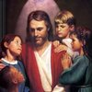  Upcoming Events  Oct. 8 – Rosary (Grade 3)  Oct.10 - Grade 3 Mass ( All are welcome)  Oct. 12 – library  Oct. 15 & 16 – Parent Teacher conference  Oct. 27 – Grandparents’ Day  BOOK IT:  Required goal for October is 250 minutes of reading, for super readers 500 + minutes of reading. | Vocabulary &Spelling: Lesson 6  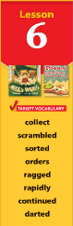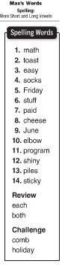  Reminders:  Read -“Max’s Words” P.186 - 213  Extra credit - Text P. 217  Spelling test on Monday, Oct. 22
Math
- compare, order, and round numbers
- test unit 1 (study guide text P. 60 – 61)
Science
Classifying Animals
Weekly Reader

Social Studies
Communities of different sizes (Chapter 2)
Map and Globe skills

Religion

- understand that prayer is a necessary part of our lives (Lesson 4)
- study Scripture Verses
-pray the rosary
- learn about patron/favorite saints

