Third Grade News From Sister Noel’s Classroom (Oct 29 - Nov.2, 2018 )
Sr.noel@sjb-school.org , http://grade3-sjbschool.weebly.com
This week we will be learning:  Language Arts  Lesson 8  A Traditional tale  Key skill  -conclusions about characters and events  Grammar & Writing  - verb tenses  - commas in a series  - summary paragraph  - concrete poem  Handwriting: cursive lowercase letters | Bible Verse for the week  I am with you; do not be afraid, for I am your God. (Isaiah 41:10)  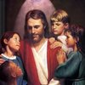  Dates to Remember  Oct. 29 - Rosary Grade 4, 3:00 PM  Oct. 30- Book it Reader Form due  Oct. 31 – Show and Tell (10:10)All Saints Party 2: 30 and 6:00 – 8:00  Nov.01 - All Saints Day (Holy Day)  Nov.02 - All Souls Day, Grandparents’ Day , All School Mass at 11:00  BOOK IT:  Required goal for “Book It” Oct. 250 minutes of reading, Super Readers -500+minutes of reading  Nov.14 - Saints dress up presentation at 2:40 PM | Vocabulary &Spelling: Lesson 8  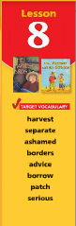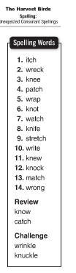  Reminders:  Read -“The Harvest Birds” P. 258 - 276  Extra credit - Text P. 279 - 281  Spelling test on Monday, Nov.5
Math
- estimate difference (Chapter 5)
- add and subtract 3 - 5 digit numbers
- count bills and coins
- compare money amounts

Science
Animal Life Cycles, Classifying Animals
Living things in Ecosystems
Weekly Reader
Social Studies
Unit 2- Communities and Geography
Map and Globe skills
Writing Activity due Nov.2
Religion
Students will
- understand that Jesus’ power to forgive and heal comes from God (Study for the test Lesson 5)
- study Scripture Verses
- Saint of the month: St. Thomas Aquinas

